ELEC362 - Week 8

Practical Exercises

1. Modify the mouse locator application such that it displays the average of all the positions at which the mouse is clicked. You can validate your application by clicking few times on a single place and observing the displayed coordinates converging to a constant value. Start from the source code provided in the lecture

Hint: Use a QVector container (<https://doc.qt.io/qt-5/qvector.html>) to save all the QMouseEvent objects, then implement a function to average the coordinates over all objects.

1. Implement the colour change functionality in the text formatting app, follow the same steps as done for the size functionality in the lecture. Start from the source code provided in the lecture.

Hints:

Create a dialog with a combo Box

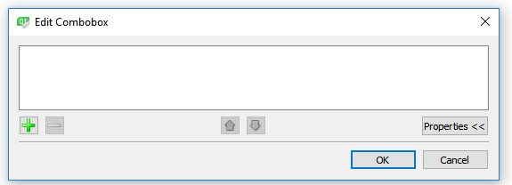Double click on the combo box widget, then add options to be chosen from the menu (the names of three colours)

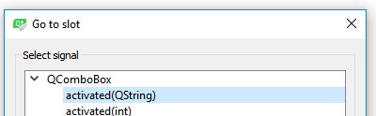Right click on the combo box widget-> Go to Slot->

The choice of the user will be saved in a variable called “arg1”, use a switch-case or if-else to set the font of the colour. You can use colours in Qt by using enumerators in Qt namespace (<https://doc.qt.io/qt-5/qt.html#GlobalColor-enum>). Something like:

